***Manav Rachna International Institute of Research and Studies***

***School of Computer Applications***

***Department of Computer Applications***

| ***Submitted By*** | |
| --- | --- |
| ***Student Name*** | **SNEHA SIDHU** |
| ***Roll No*** | ***24/SCA/BCA(AI&ML)/065*** |
| ***Programme*** | ***BCA (AI&ML)*** |
| ***Semester*** | ***1st Semester*** |
| ***Section/Group*** | ***I B*** |
| ***Department*** | ***Computer Applications*** |
| ***Batch*** | ***2024-2027*** |
|  | |
| ***Submitted To*** | |
| ***Faculty Name*** | ***Mrs. Sakshi Gupta*** |



**INDEX**

|  |  |  |
| --- | --- | --- |
| S.No | Experiment | Remark |
|  | Create a simple HTML page using basic tags. |  |
|  | Create a web page that displays your name to the screen. |  |
|  | Create a web page and show the output from 1 to 10 in separate lines. |  |
|  | Create a web page and show the output from 1 to 10 in separate lines, each number being in different color. |  |
|  | How do I make a picture as a background on my web pages? |  |
|  | Create a web page to print a paragraph with 4-5 sentences, each sentence shall have a different font. |  |
|  | Write HTML code to print a paragraph that is description of a book, it shall include the title of the book, its author name; name and title should be underlined and all adjectives shall be bold and Italics. |  |
|  | Write HTML code to print your name using Heading tag, every letter shall be of different heading size. |  |
|  | Write HTML code to print the sequence of numbers 1-20. Each number shall be in different line with number 2 next to it as subscript, an equal sign and the result. |  |
|  | Write HTML code to display an image with border of size with width 200, height 200 pixels, leaving Hspace and Vspace of your choice with image hanging in the right side on the screen. |  |
|  | Write HTML code to create a web page with heading. The heading shall be displayed at the top-center of the page and the image shall be at the centre, just below the heading. |  |
|  | Write HTML code using Multimedia tags. |  |
|  | Create a Table using Rowspan and Colspan taking example of student Record. |  |
|  | Write HTML code using table tag <table> and cellpadding and cell spacing as its attributes. |  |
|  | Create unordered, ordered and definition Lists taking example of your subjects in MCA IST, IInd and IIIrd Semester. |  |
|  | Write HTML code using <frameset> and <frame> tag with all its attributes |  |
|  | Write HTML code to design a form in HTML using controls and buttons such as Textbox, Text area, password, submit button, browse button, drop-down menu |  |
|  | Write HTML code to design a Registration Form in HTML. |  |
|  | Write HTML code to design a student admission Form in HTML. |  |
|  | Create a proper home page of your own using any components and styles. |  |
|  | Write HTML code for including Local hyperlinking in a web page. |  |
|  | Write HTML code for including Inter hyperlinking in a web page. |  |
|  | Write HTML code for including External hyperlinking in a web page. |  |
|  | Write code to show External CSS with HTML code |  |
|  | Write code to show Internal CSS with HTML code. |  |
|  | Write code to show Inline CSS with HTML code. |  |
|  | Write a program to add two numbers using form in JavaScript. |  |
|  | Write a program in JavaScript to swap two images using on mouse over event. |  |
|  | Write a simple JavaScript program to sort an array |  |
|  | Write a JavaScript program to take as input three numbers from the user. Find the minimum and maximum of the three numbers. Print the following output in BOLD in the following format:  MINIMUM =        MAXIMUM = |  |

ASSIGNMENT

Q1. create a html page using basic tags.

<!DOCTYPE html>

<html>

<head>

<title> environment </title>

<body>

</html>

<h1> The environment gives us countless benefits that we can't repay our entire life. </h1>

<h2> As they are connected with the forest, trees, animals, water, and air. </h2>

<h3> The forest and trees filter the air and absorb harmful gases. </h3>

<h4> Plants purify water, reduce the chances of flood maintain natural balance and many others. </h4>

<h5> The environment provides us fertile land, water, air, livestock and many essential things for survival. </h5>

<h6> It regulates the vital systems that are essential for the ecosystem. </h6>

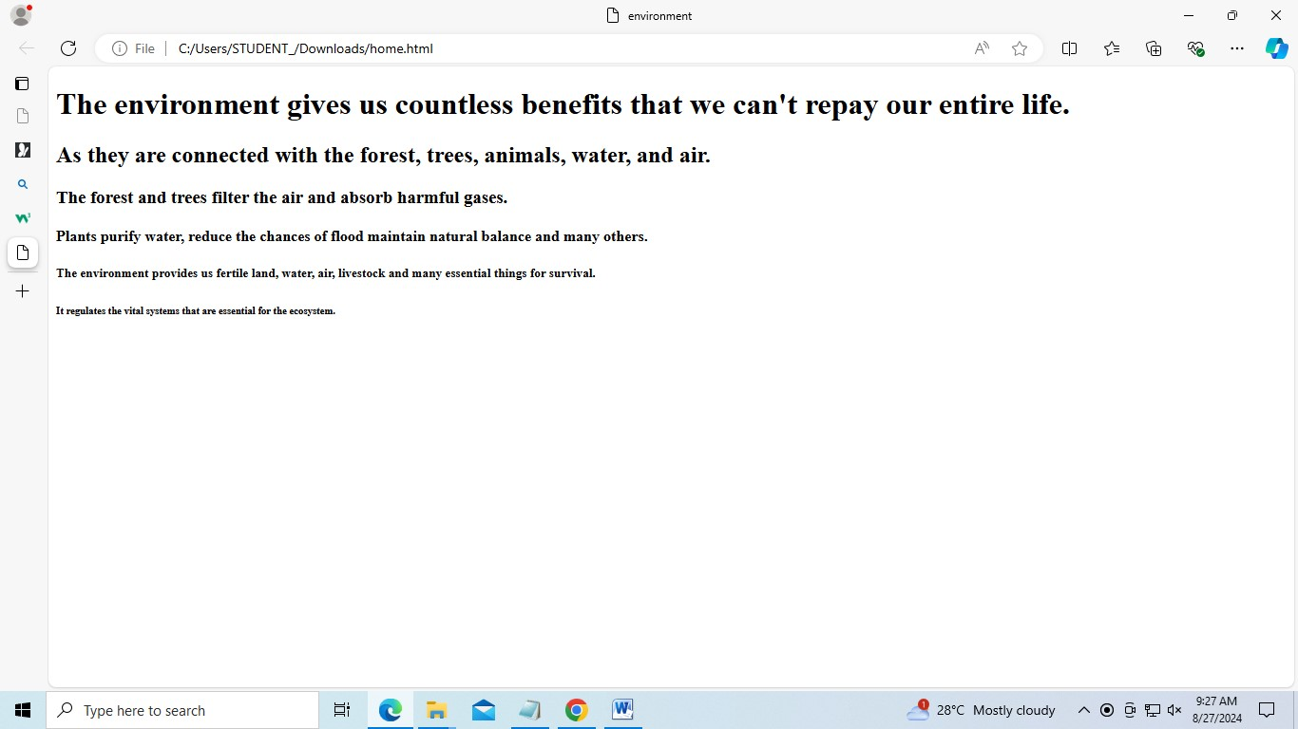

Q2. create a page that displays your name to the screen.

<html>

<head>

<title> my first html page </title>

</head>

<body>

<h1>"SNEHA SIDHU"</h1>

</body>

</html>

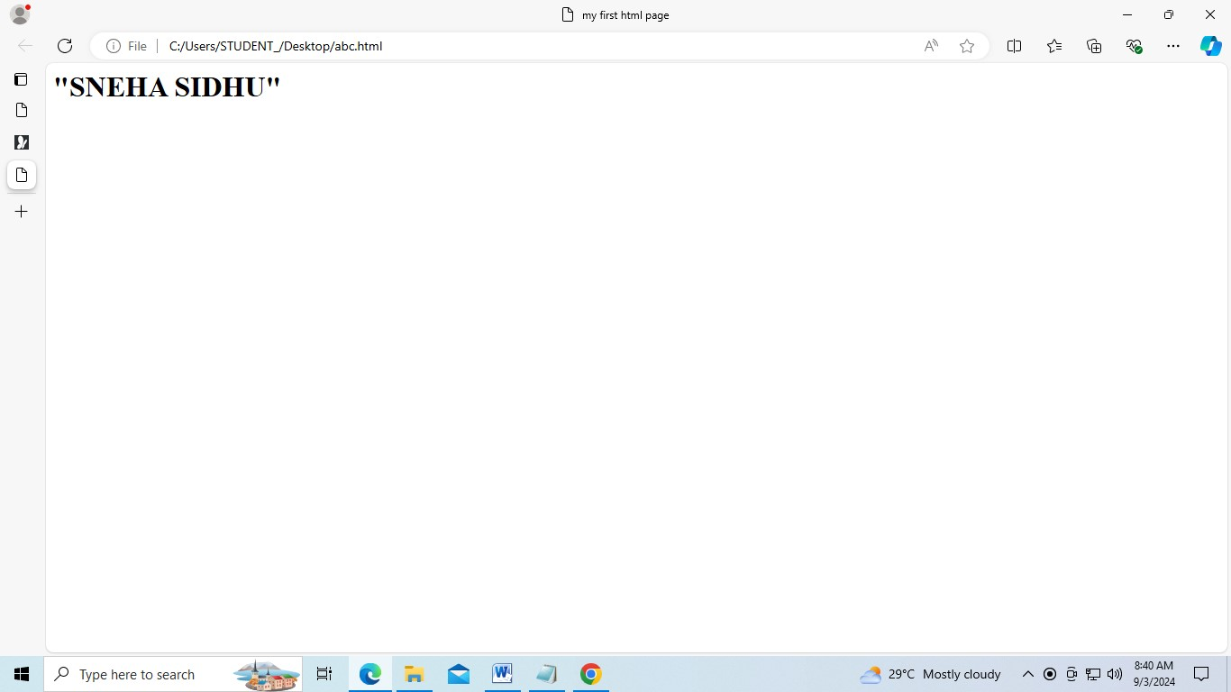

Q3. create a webpage and show the output from 1 to 10 in separate lines.

<html>

<head>

<title> numbers 1 to 10 </title>

</head>

<body>

1<br>

2<br>

3<br>

4<br>

5<br>

6<br>

7<br>

8<br>

9<br>

10

</body>

</html>

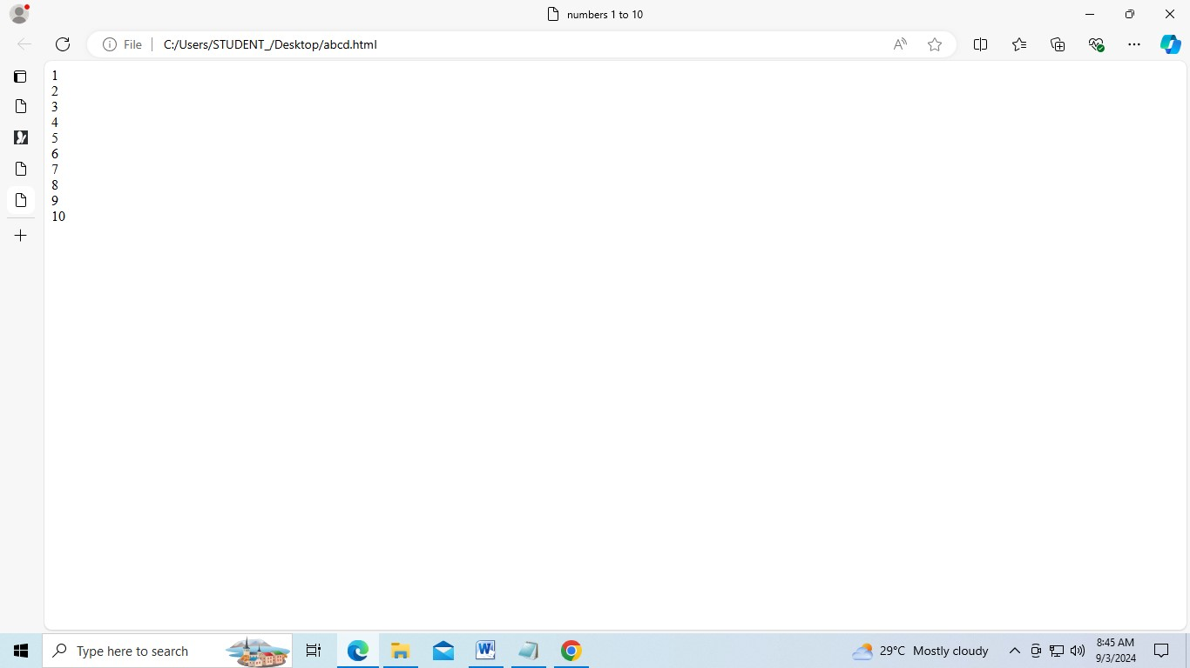

Q4. create a web page and show the output 1 to 10 in separate lines, each number being in different color.

<html>

<head>

<title>number colors</title>

</head>

<body>

<font color="red">1</font><br>

<font color="orange">2</font><br>

<font color="yellow">3</font><br>

<font color="green">4</font><br>

<font color="blue">5</font><br>

<font color="indigo">6</font><br>

<font color="violet">7</font><br>

<font color="pink">8</font><br>

<font color="brown">9</font><br>

<font color="grey">10</font><br>

</body>

</html>

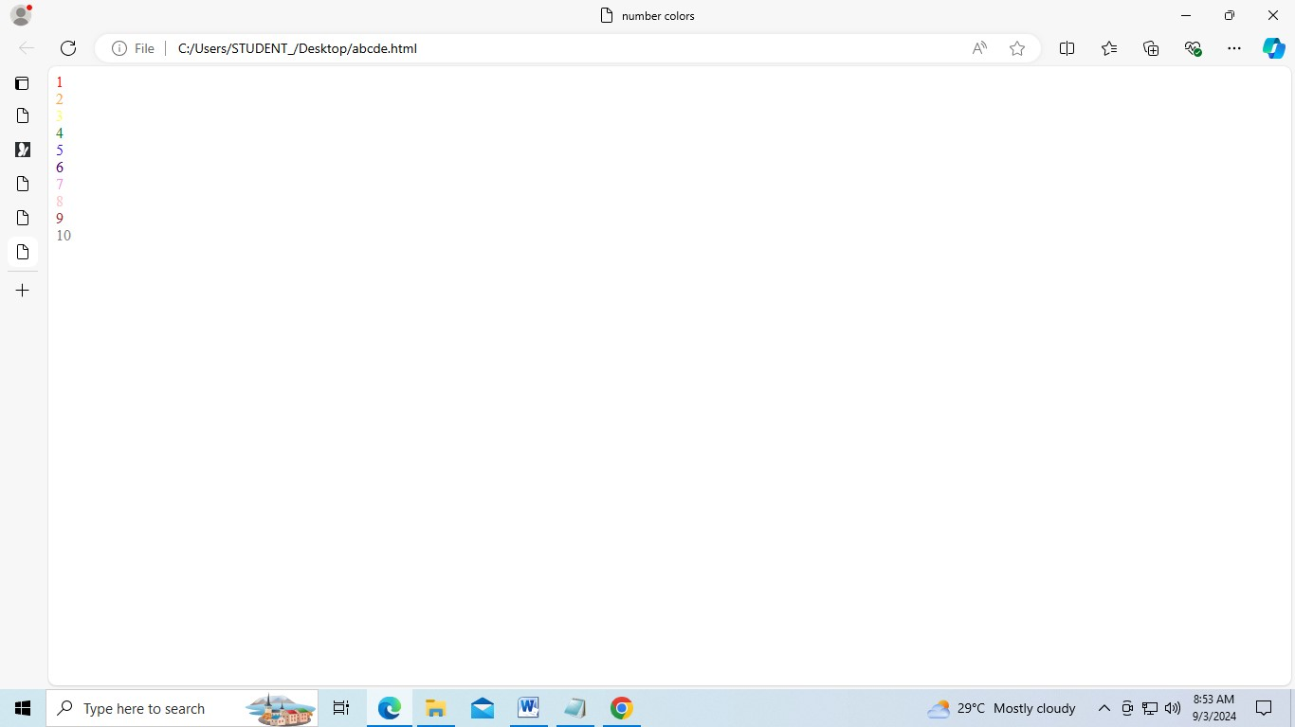

Q5. how do I make a picture as a background on my pages?

<html>

<head>

<title> background image </title>

</head>

</body>

<body

background="[https://as2.ftcdn.net/v2/jpg/05/68/98/15/1000_F_568981524_2irG4VUSs06xbahAihTpku SfxKkw8FqX.jpg](https://as2.ftcdn.net/v2/jpg/05/68/98/15/1000_F_568981524_2irG4VUSs06xbahAihTpkuSfxKkw8FqX.jpg) ["](https://as2.ftcdn.net/v2/jpg/05/68/98/15/1000_F_568981524_2irG4VUSs06xbahAihTpkuSfxKkw8FqX.jpg)>

</body>

</html>



Q6 create a web page to print a paragraph with 4-5 sentence, each sentences shall have a different font?

<HTML>

<head>

<title>paragraph with different fonts</title>

</head>

<body>

<h1>SNEHA SIDHU </h1>

<p>

<B>my name is Sneha Sidhu.</B><br>

<I>i am studying at manav rachna institute of internationls reserch and studies pursuing bca ai ml it is situated in faridabad,india</I><br>

<U>i am looking forward to become ai engineer and my course suits my goals perfectly </U><br>

<B>my hobbies are doing editing in my free time and playing badminton on weekends</B></br> </p>

</body>

</html>

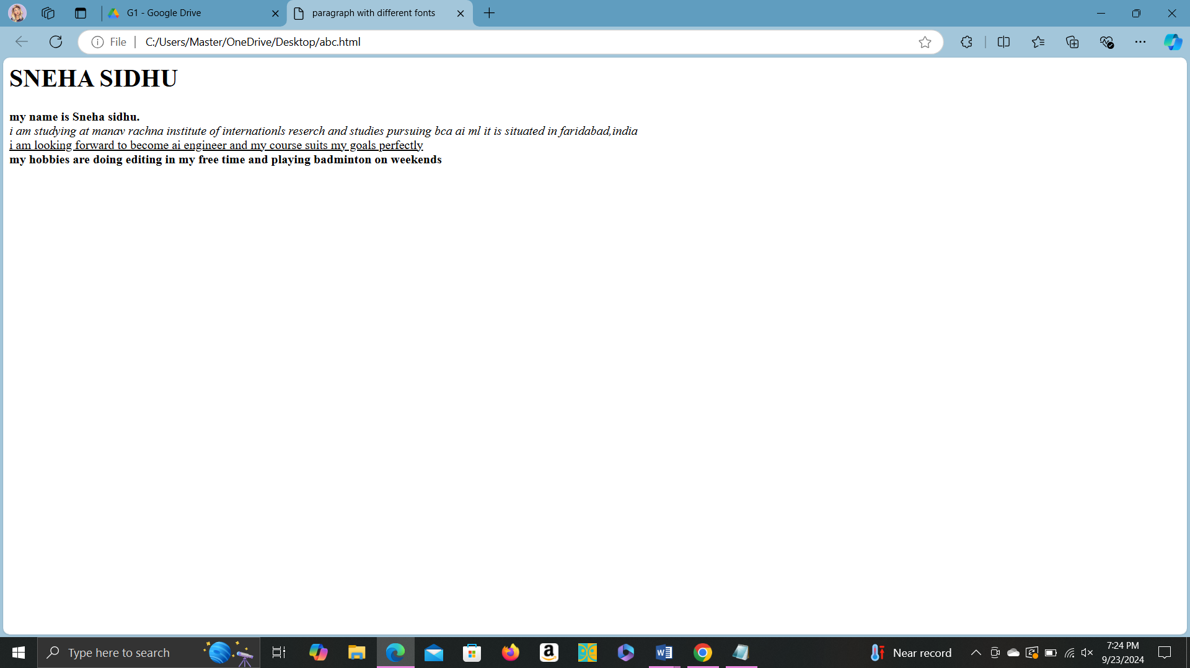

Q7 write a html code to print a paragraph that is a description book, it shall include the title of the book, its author name; name and title should be underlined and all adjectives shall be in bold italics

<html>

<head>

<title>Book Description</title>

</head>

<body>

<h1><u><B>The Great Gatsby</u></B></h1>

<p>AUTHOR NAME:<u>F.Scott Fitzgerald</u><br>

The Great Gatsby is a <B>classic novel</B> set in the <i>roaring</i> 1920s. It explores the

<B>glamorous</B> and <B>decadent</B> lifestyles of the era through the eyes of the

<i>mysterious</i >and wealthy Jay Gatsby. The story delves into themes of <B>unrequited love</B>, moral decay, and the <i>elusive nature</i> of the American Dream.</p>

</body>

</html>

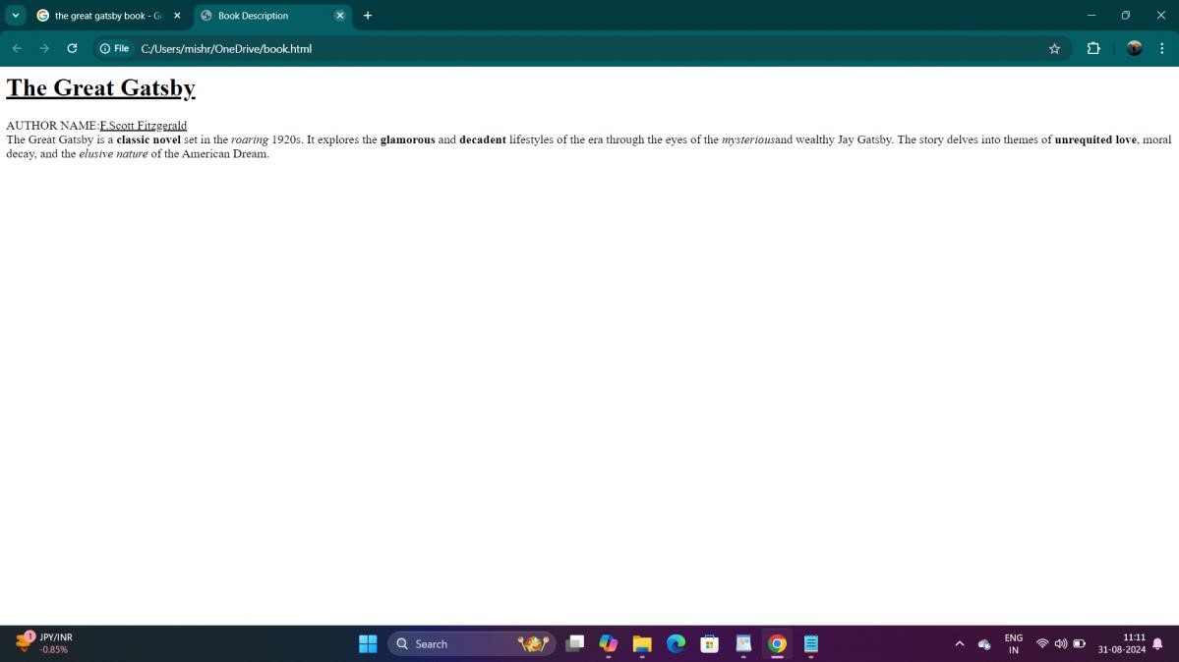

Q8 write a html code to print name using heading tag, every letter shall be in different heading size

<html>

<head>

<title>Name in Different Heading Sizes</title>

</head>

<body>

<h1>A</h1>

<h2>b</h2>

<h3>h</h3>

<h4>i</h4>

<h5>n</h5>

<h6>a</h6>

<h1>v</h1>

<h2> </h2> <!-- Space between names -->

<h3>M</h3>

<h4>i</h4>

<h5>s</h5>

<h6>h</h6>

<h1>r</h1>

<h2>a</h2>

</body>

</html>

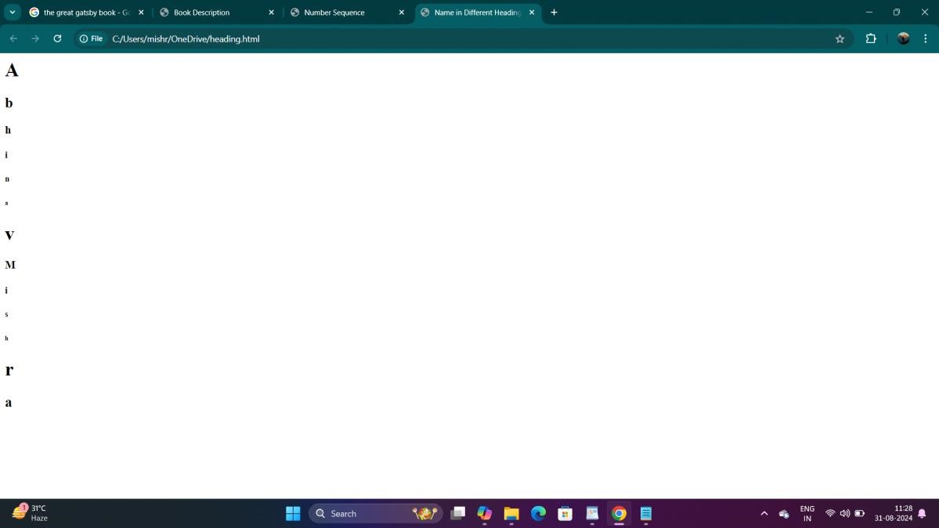

Q9 write html code to print the sequence of numbers 1-20. each number shall be in different line with number 2 next to it as subscript, an equal sign and the result.

<html>

<head>

<title>Number Sequence</title>

</head>

<body>

<p>1<sub>2</sub> = 1</p>

<p>2<sub>2</sub> = 4</p>

<p>3<sub>2</sub> = 9</p>

<p>4<sub>2</sub> = 16</p>

<p>5<sub>2</sub> = 25</p>

<p>6<sub>2</sub> = 36</p>

<p>7<sub>2</sub> = 49</p>

<p>8<sub>2</sub> = 64</p>

<p>9<sub>2</sub> = 81</p>

<p>10<sub>2</sub> = 100</p>

<p>11<sub>2</sub> = 121</p>

<p>12<sub>2</sub> = 144</p>

<p>13<sub>2</sub> = 169</p>

<p>14<sub>2</sub> = 196</p>

<p>15<sub>2</sub> = 225</p>

<p>16<sub>2</sub> = 256</p>

<p>17<sub>2</sub> = 289</p>

<p>18<sub>2</sub> = 324</p>

<p>19<sub>2</sub> = 361</p>

<p>20<sub>2</sub> = 400</p>

</body>

</html>

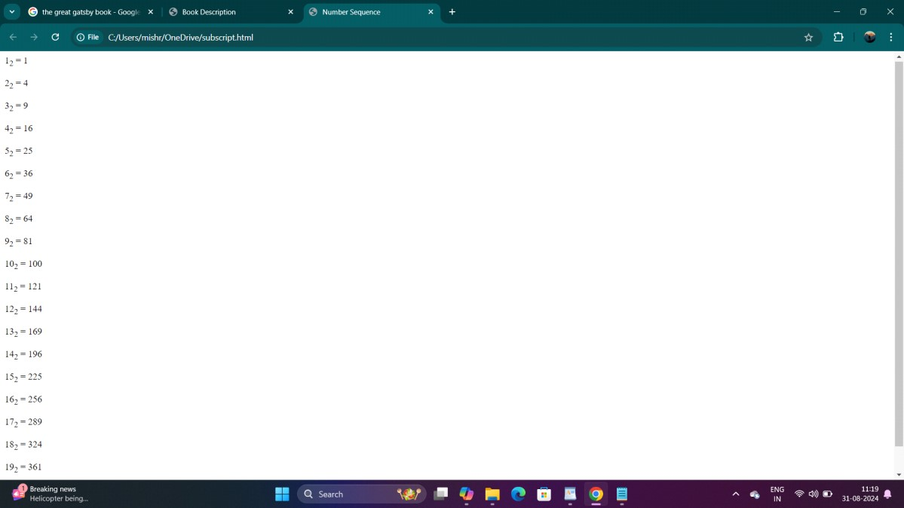

Q 10 write a html code to display an image with border of size with width 200 height 200 pixels, leaving H Space and V Space of your choice with image hanging in the right side on the screen.

:- <HTML>

<head>

<title>Image Display</title>

<style> img { border: 2px solid black; width: 200px; height: 200px; display: block; margin-left: auto; margin-right: 0; margin-top: 20px; margin-bottom: 20px; }

</style>

</head>

<body>

<img src="https://m.media-amazon.com/images/I/81o8PrHjBqL._AC_UF1000,1000_QL80_.jpg" alt="Sample Image">

</body>

</html>

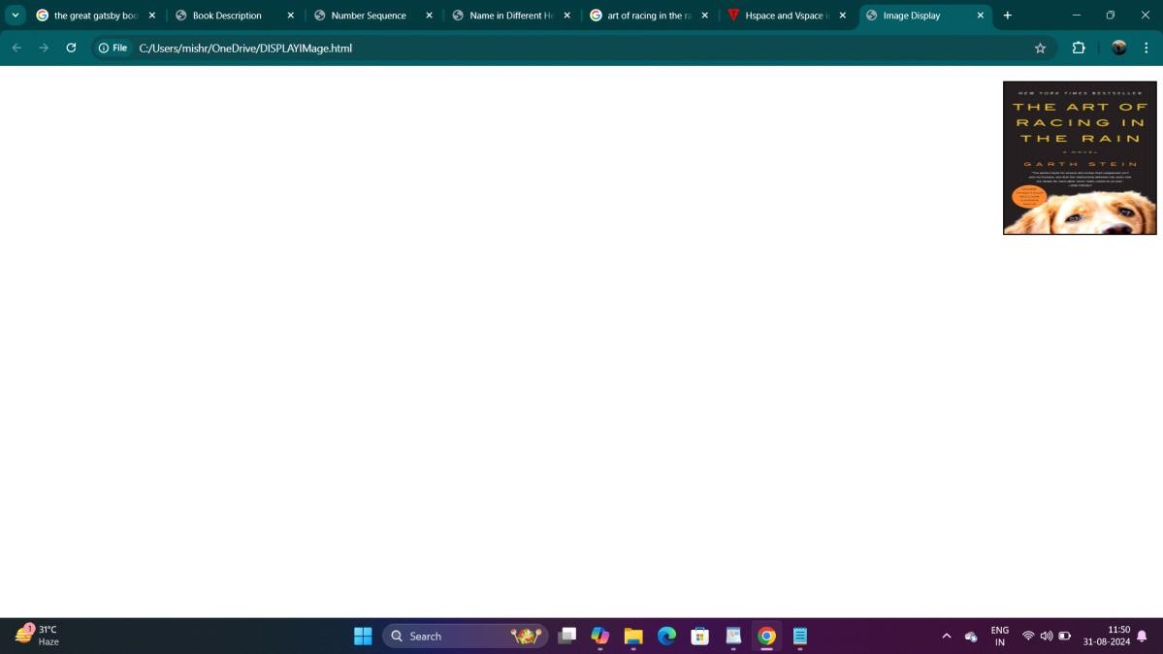

Q 11 write a html code to create a web page with heading. the heading shall be displayed at the top-center of the page and the image shall be at the center, just below the heading.

<html>

<head>

<title>Centered Heading and Image</title>

<style> body { margin: 0; font-family: Arial, sans-serif; text-align: center; justify-content: center; align-items: center;

</style>

</head>

<body>

<h1>The Triumph of India 2024</h1>

<img src="https://www.financialexpress.com/wp-content/uploads/2024/06/T20-World-Cup-2024-1.jpg" alt="T20 World Cup 2024">

</body>

</html>

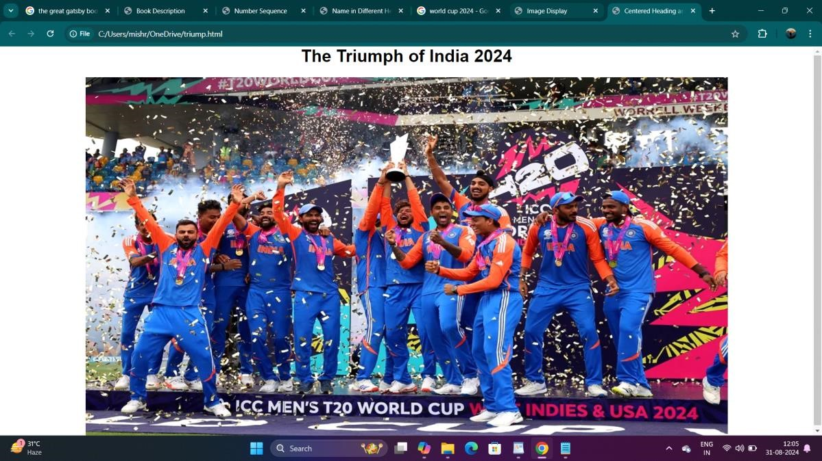

Q12 Write HTML code using Multimedia tags.

<html>

<head>

<title>Multimedia Example</title>

</head>

<body>

<h2>Image Example</h2>

<img src="C:\Users\HP\OneDrive\Desktop\scenry" alt="Beautiful Scenery" width="500">

<!-- Embedding a video -->

<h2>Video Example</h2>

<video width="500" controls>

<source src="C:\Users\HP\OneDrive\Desktop\scenery video" type="video/mp4">

</video>

<!-- Embedding audio -->

<h2>Audio Example</h2>

<audio controls>

<source src="sample-audio.mp3" type="audio/mpeg"

</audio>

</body>

</html>

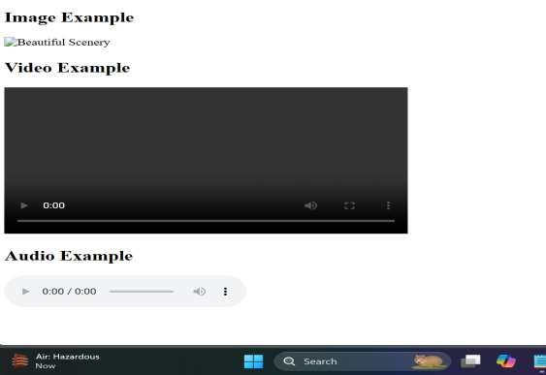

Q13 Create a Table using Rowspan and Colspan taking example of student Record.

<html>

<head>

<title>Student Record</title>

<style> table { width: 80%; border-collapse: collapse; margin: 20px auto;

} th, td {

border: 1px solid #000; padding: 8px; text-align: center;

}

</style>

</head>

<body>

<table>

<tr>

<th rowspan="2">Student ID</th>

<th rowspan="2">Name</th>

<th colspan="3">Subjects</th>

</tr>

<tr>

<th>Math</th>

<th>Science</th>

<th>English</th>

</tr>

<tr>

<td>1</td>

<td>Riya</td>

<td>85</td>

<td>90</td>

<td>78</td>

</tr>

<tr>

<td>2</td>

<td>Priya</td>

<td>88</td>

<td>92</td>

<td>80</td>

</tr>

</table>

</body>

</html>

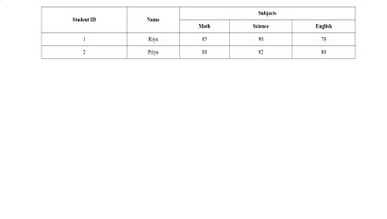

Q14 Write HTML code using table tag <table> and cellpadding and cellspacing as its attributes.

<html>

<head>

<title>Student Record Table</title>

<style> table {

border: 1px solid #000; margin: 20px auto; border-collapse: collapse;

} th, td {

border: 1px solid #000;

padding: 10px; text-align: center;

}

</style>

</head>

<body>

<table cellpadding="10" cellspacing="5">

<tr>

<th>Student ID</th>

<th>Name</th>

<th>Math</th>

<th>Science</th>

<th>English</th>

</tr>

<tr>

<td>1</td>

<td>Riya</td>

<td>85</td>

<td>90</td>

<td>78</td>

</tr>

<tr>

<td>2</td>

<td>Zaen</td>

<td>88</td>

<td>92</td>

<td>80</td>

</tr>

</table>

</body>

</html>

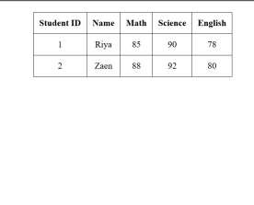

Q15 Create unordered, ordered and definition Lists taking example of your subjects in MCA IST, IInd and IIIrd Semester.

<html>

<head>

<title>MCA Subjects</title>

</head>

<body>

<h1>MCA IST Subjects</h1>

<!-- Unordered List -->

<h2>IInd Semester Subjects</h2>

<ul>

<li>Database Management Systems</li>

<li>Data Structures and Algorithms</li>

<li>Software Engineering</li>

<li>Web Technologies</li>

</ul>

<!-- Ordered List -->

<h2>IIIrd Semester Subjects</h2>

<ol>

<li>Operating Systems</li>

<li>Computer Networks</li>

<li>Mobile Application Development</li> <li>Artificial Intelligence</li>

</ol>

<!-- Definition List -->

<h2>Subject Definitions</h2>

<dl>

<dt>Database Management Systems</dt>

<dd>A system for creating and managing databases.</dd>

<dt>Data Structures and Algorithms</dt>

<dd>The study of data organization and the algorithms that operate on them.</dd>

<dt>Software Engineering</dt>

<dd>The application of engineering principles to software development.</dd>

<dt>Web Technologies</dt>

<dd>Technologies used for developing web applications.</dd>

<dt>Operating Systems</dt>

<dd>The software that manages computer hardware and software resources.</dd>

<dt>Computer Networks</dt>

<dd>The study of interconnecting computers to share resources.</dd>

<dt>Mobile Application Development</dt>

<dd>The process of creating software applications for mobile devices.</dd>

<dt>Artificial Intelligence</dt>

<dd>The simulation of human intelligence processes by machines.</dd>

</dl>

</body>

</html>

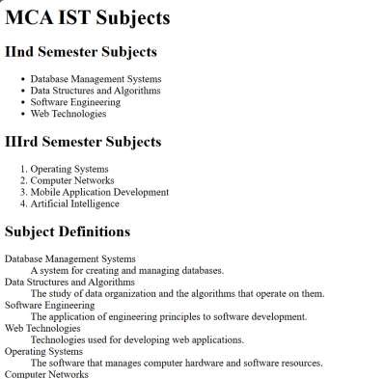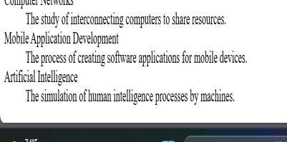

Q16 Write HTML code using <frameset> and <frame> tag with all its attributes

<html>

<head>

<title>Frameset Example</title>

</head>

<frameset rows="50%,50%" border="2" frameborder="yes" framespacing="5">

<frame src="header.html" name="header" scrolling="no" noresize>

<frame src="content.html" name="content" scrolling="yes"> </frameset>

<noframes>

<body>

<p>Your browser does not support frames. Please consider updating your browser.</p>

</body>

</noframes>

</html>

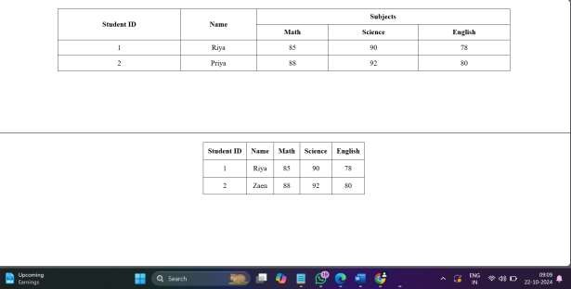

Q17 Write HTML code to design a form in HTML using controls and buttons such as Teaxtbox, Textarea

<html>

<head>

<title>Sample Form</title>

<style> body {

font-family: Arial, sans-serif; margin: 20px;

}

form {

max-width: 400px; margin: auto;

} label { display: block; margin-top: 10px;

}

input, textarea, select { width: 100%; padding: 8px; margin-top: 5px; box-sizing: border-box;

}

button { margin-top: 10px; padding: 10px; background-color: #4CAF50; color: white; border: none; cursor: pointer;

}

button:hover { background-color: #45a049;

}

</style>

</head>

<body>

<h1>Feedback Form</h1>

<form action="/submit" method="post">

<label for="name">Name:</label> <input type="text" id="name" name="name" \>

<label for="email">Email:</label>

<input type="email" id="email" name="email" \>

<label for="feedback">Feedback:</label>

<textarea id="feedback" name="feedback" rows="4" ></textarea>

<label>Preferred Contact Method:</label>

<input type="radio" id="phone" name="contact" value="phone">

<label for="phone">Phone</label>

<input type="radio" id="email_contact" name="contact" value="email" checked>

<label for="email_contact">Email</label>

<label>Subscribe to Newsletter:</label>

<input type="checkbox" id="subscribe" name="subscribe" value="yes">

<label for="subscribe">Yes, I want to receive updates</label>

<button type="submit">Submit</button>

</form>

</body>

</html>

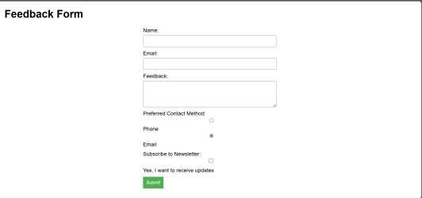

Q18 Write HTML code to design a Registration Form in HTML.

<html>

<head>

<title>Registration Form</title>

<style> body {

font-family: Arial; margin: 20px; background-color:White;

}

form { max-width: 500px; margin: auto; background: white; padding: 20px; border-radius: 5px; box-shadow: 0 0 10px

} label { display: block; margin-top: 10px;

}

input, select, textarea { width: 100%; padding: 8px; margin-top: 5px; box-sizing: border-box;

}

button { margin-top: 10px; padding: 10px; background-color:Black; color: white; border: none; cursor: pointer; width: 100%;

}

button:hover { background-color: Blue;

}

</style>

</head>

<body>

<h1>Registration Form</h1>

<form action="/submit" method="post">

<label for="username">Username:</label>

<input type="text" id="username" name="username" required>

<label for="email">Email:</label>

<input type="email" id="email" name="email" required> <label for="password">Password:</label>

<input type="password" id="password" name="password" required>

<label for="confirm-password">Confirm Password:</label>

<input type="password" id="confirm-password" name="confirm-password" required>

<label for="dob">Date of Birth:</label>

<input type="date" id="dob" name="dob" required>

<label for="gender">Gender:</label>

<select id="gender" name="gender" required>

<option value="">Select Gender</option>

<option value="male">Male</option>

<option value="female">Female</option>

<option value="other">Other</option>

</select>

<label for="address">Address:</label>

<textarea id="address" name="address" rows="4" required></textarea>

<label for="phone">Phone Number:</label>

<input type="tel" id="phone" name="phone" required>

<button type="submit">Register</button>

</form>

</body>

</html>

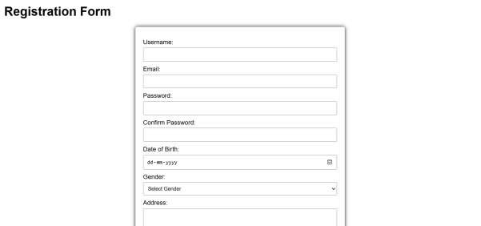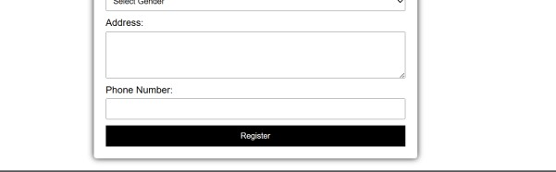

Q19 Write HTML code to design a student admission Form in HTML.

<html>

<head>

<title>Student Admission Form</title>

<style> body { font-family: Arial; margin: 20px; background-color: Green;

}

form { max-width: 600px; margin: auto; background: white; padding: 20px; border-radius: 5px; box-shadow: 0 0 10px ;

} label { display: block; margin-top: 10px;

}

input, select, textarea { width: 100%; padding: 8px; margin-top: 5px; box-sizing: border-box;

}

button { margin-top: 10px; padding: 10px; background-color: White; color: white; border: none; cursor: pointer; width: 100%;

}

button:hover { background-color:Red;

}

</style>

</head>

<body>

<h1>Student Admission Form</h1>

<form action="/submit" method="post">

<label for="fullName">Full Name:</label>

<input type="text" id="fullName" name="fullName" \>

<label for="dob">Date of Birth:</label>

<input type="date" id="dob" name="dob" \>

<label for="gender">Gender:</label>

<select id="gender" name="gender" \>

<option value="">Select Gender</option>

<option value="male">Male</option>

<option value="female">Female</option>

<option value="other">Other</option>

</select>

<label for="address">Address:</label>

<textarea id="address" name="address" rows="4" ></textarea>

<label for="email">Email:</label>

<input type="email" id="email" name="email" \> <label for="phone">Phone Number:</label>

<input type="Number" id="phone" name="phone" \>

<label for="course">Course Applied For:</label>

<select id="course" name="course" required>

<option value="">Select Course</option>

<option value="bsc">B.Sc</option>

<option value="msc">M.Sc</option>

<option value="bcom">B.Com</option>

<option value="mcom">M.Com</option>

<option value="bca">BCA</option>

<option value="mca">MCA</option>

</select>

<label for="previousSchool">Previous School/College:</label>

<input type="text" id="previousSchool" name="previousSchool" required>

<label for="academicYear">Academic Year:</label>

<select id="academicYear" name="academicYear" required>

<option value="">Select Academic Year</option>

<option value="2024">2024</option>

<option value="2025">2025</option>

<option value="2026">2026</option>

</select>

<button type="submit">Submit Application</button>

</form>

</body>

</html>

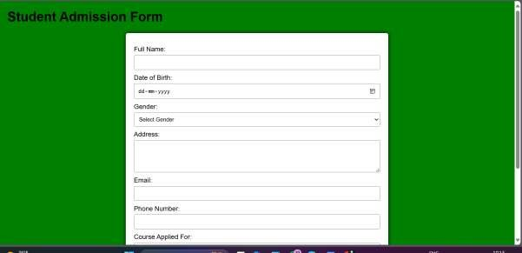

Q20 Create a proper home page of your own using any components and styles.

<html>

<head>

<title>My Homepage</title>

<style> body {

font-family: Arial; margin: 0; padding: 0; background-color:White;

}

header { background:White; color: white; padding: 10px 0; text-align: center;

} nav { margin: 0; padding: 10px 0;

}

nav a { color: white; margin: 0 15px; text-decoration: none; font-weight: bold;

}

nav a:hover { text-decoration: underline;

}

.hero { height: 400px; display: flex; align-items: center; justify-content: center; color: white; text-shadow: 2px 2px 4px;

}

.hero h1 { font-size: 3em;

}

.container { padding: 20px;

}

.section { margin: 20px 0; padding: 20px; background: white; border-radius: 5px; box-shadow: 0 0 10px;

}

footer { background: Red; color: white; text-align: center; padding: 10px 0; position: relative; bottom: 0; width: 100%;

}

</style>

</head>

<body>

<header>

<h1>Welcome to My Homepage</h1>

<nav>

<a href="#about">About</a>

<a href="#services">Services</a>

<a href="#contact">Contact</a>

</nav>

</header>

<div class="hero">

<h1>Your Journey Begins Here</h1>

</div>

<div class="container">

<div id="about" class="section">

<h2>About Me</h2>

<p>Hello! I am a web developer with a passion for creating beautiful and functional websites. I love coding and constantly learning new technologies.</p>

</div>

<div id="services" class="section">

<h2>Services</h2>

<ul>

<li>Web Development</li>

<li>UI/UX Design</li>

<li>SEO Optimization</li>

<li>Content Creation</li>

</ul>

</div>

<div id="contact" class="section">

<h2>Contact Me</h2>

<p>If you would like to get in touch, feel free to reach out via email at <a

href="mailto:example@example.com">example@example.c om</a>.</p>

</div>

</div>

<footer>

<p>&copy; 2024 My Homepage. All rights reserved.</p>

</footer>

</body>

</html>

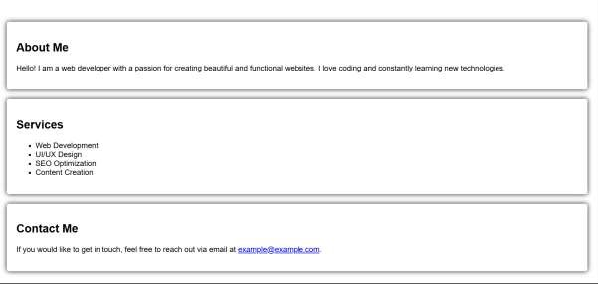

Q21 Write HTML code for including Local hyperlinking in a web page.

<html>

<head>

<title>Local Hyperlinking Example</title>

<style> body {

font-family: Arial, sans-serif; margin: 20px;

}

section {

margin-bottom: 40px;

}

</style>

</head>

<body>

<h1>Local Hyperlinking Example</h1>

<ul>

<li><a href="#section1">Go to Section 1</a></li>

<li><a href="#section2">Go to Section 2</a></li> <li><a href="#section3">Go to Section 3</a></li>

</ul>

<section id="section1">

<h2>Section 1</h2>

<p>This is the content of section 1.</p>

<a href="#top">Back to Top</a>

</section>

<section id="section2">

<h2>Section 2</h2>

<p>This is the content of section 2.</p>

<a href="#top">Back to Top</a>

</section>

<section id="section3">

<h2>Section 3</h2>

<p>This is the content of section 3.</p>

<a href="#top">Back to Top</a>

</section>

</body>

</html>

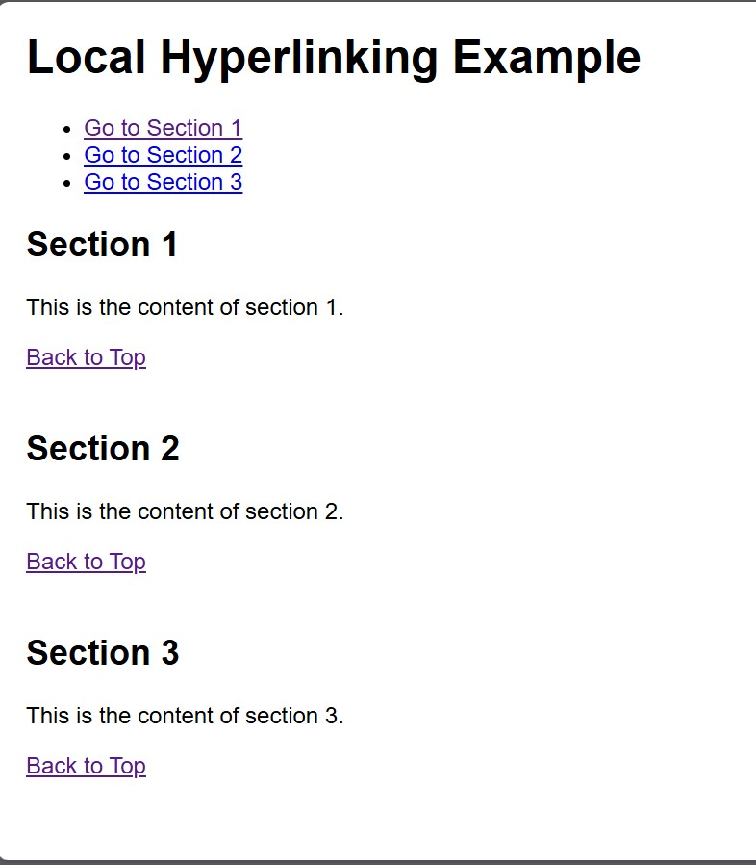

Q22 Write HTML code for including Inter hyperlinking in a web page.

<html>

<head>

<title>Interlinking Example</title>

<style> body {

font-family: Arial, sans-serif;

}

section { margin: 20px 0;

} nav {

margin-bottom: 20px;

}

</style>

</head>

<body>

<nav>

<ul>

<li><a href="#section1">Go to Section 1</a></li>

<li><a href="#section2">Go to Section 2</a></li> <li><a href="#section3">Go to Section 3</a></li>

</ul>

</nav>

<section id="section1">

<h2>Section 1</h2>

<p>This is the first section of the page. You can link to other sections using the navigation above.</p>

<a href="#top">Back to Top</a>

</section>

<section id="section2">

<h2>Section 2</h2>

<p>This is the second section. Use the navigation to jump to other sections.</p>

<a href="#top">Back to Top</a>

</section>

<section id="section3">

<h2>Section 3</h2>

<p>This is the third section. Don't forget to check out the other sections!</p>

<a href="#top">Back to Top</a>

</section>

<a id="top"></a>

</body>

</html>

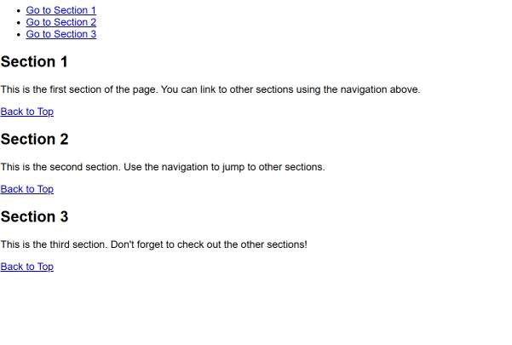

Q23 Write HTML code for including External hyperlinking in a web page.

<html>

<head>

<title>External Hyperlinking Example</title>

<style> body {

font-family: Arial, sans-serif;

} a { color: blue; text-decoration: none;

}

a:hover {

text-decoration: underline;

}

</style>

</head>

<body>

<h1>Welcome to My Web Page</h1>

<p>Here are some useful external links:</p>

<ul>

<li><a href="https://www.wikipedia.org" target="_blank" rel="noopener noreferrer">Visit Wikipedia</a> - A free online encyclopedia.</li>

<li><a href="https://www.github.com" target="_blank" rel="noopener noreferrer">Check out GitHub</a> - A platform for version control and collaboration.</li>

<li><a href="https://www.openai.com" target="_blank" rel="noopener noreferrer">Learn about OpenAI</a> - An AI research organization.</li>

</ul>

<p>Feel free to explore the links above!</p>

</body>

</html>

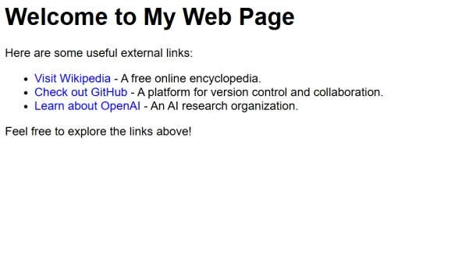

Q24 Write code to show External CSS with HTML code.

<html>

<head>

<title>External CSS Example</title>

<link rel="stylesheet" href="styles.css"> <!-- Linking external CSS -->

</head>

<body> <style> body {

background-color: #f0f0f0; font-family: Arial, sans-serif;

}

h1 { color: #333; text-align: center;

} p { color: #555; font-size: 18px; padding: 20px;

}

</style>

<h1>Welcome to My Website</h1>

<p>This is a simple example of using external CSS with HTML.</p>

</body>

</html>

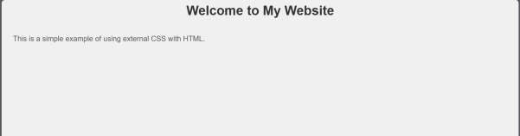

Q25 Write code to show Internal CSS with HTML code.

<html>

<head>

<title>Internal CSS Example</title>

<style> body { background-color:Wite; font-family: Arial, sans-serif;

}

h1 {

color:Red; text-align: center;

}

p {

color:Blue; font-size: 18px; padding: 20px;

}

</style>

</head>

<body>

<h1>Welcome to My Website</h1>

<p>This is a simple example of using internal CSS with HTML.</p>

</body>

</html>

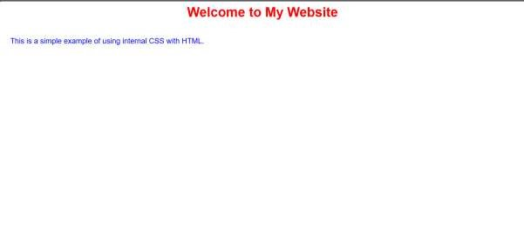

Q26 Write code to show Inline CSS with HTML code.

<html>

<head>

<title>Inline CSS Example</title>

</head>

<body style="background-color: Black; font-family: Arial, sans-serif;">

<h1 style="color:White; text-align: center;">Welcome to My Website</h1>

<p style="color: White; font-size: 25px; padding: 30px;">

This is a simple example of using inline CSS with HTML.

</p>

</body>

</html>

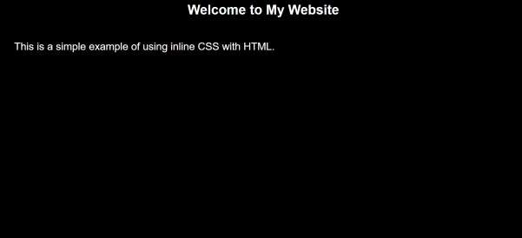

Q 27 Write a program to add two numbers using form in JavaScript.

**Input:**

<html>

<head>

<title>Add Two Numbers</title>

<script>

function addNumbers() {

var num1 = parseFloat(document.getElementById('num1').value);

var num2 = parseFloat(document.getElementById('num2').value);

if (isNaN(num1) || isNaN(num2)) {

alert("Please enter valid numbers.");

} else {

var sum = num1 + num2;

document.getElementById('result').innerHTML = "Result: " + sum;

}

}

</script>

</head>

<body>

<h1>Simple Addition Form</h1>

<!-- Form to input two numbers -->

<form onsubmit="event.preventDefault(); addNumber

<label for="num1">Number 1:</label>

<input type="number" id="num1" required><br><br>

<label for="num2">Number 2:</label>

<input type="number" id="num2" required><br><br>

<button type="submit">Add Numbers</button>

</form>

<div id="result"></div>

</body>

</html>

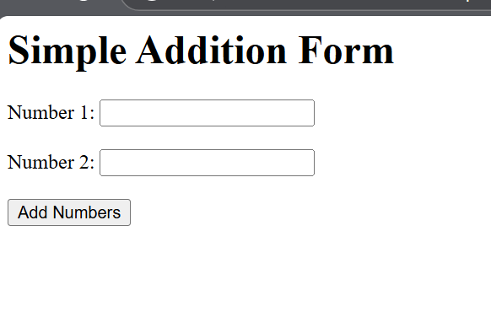

Q28 Write a program in JavaScript to swap two images using on mouseover event.

Input:

<html>

<head>

<title>Swap Images on Mouseover</title>

<style>

img {

width: 300px; /* Set a fixed size for the images */

height: auto;

cursor: pointer;

transition: all 0.3s ease;

}

</style>

<script>

function swapImages() {

var image1 = document.getElementById('image1');

var image2 = document.getElementById('image2');

var tempSrc = image1.src;

image1.src = image2.src;

image2.src = tempSrc;

}

</script>

</head>

<body>

<h1>Swap Images on Mouseover</h1>

<img id="image1" src="https://via.placeholder.com/300x200.png?text=Image+1" alt="Image 1" onmouseover="swapImages()" />

<img id="image2" src="https://via.placeholder.com/300x200.png?text=Image+2" alt="Image 2" />

<p>Hover over the first image to swap them.</p>

</body>

</html>

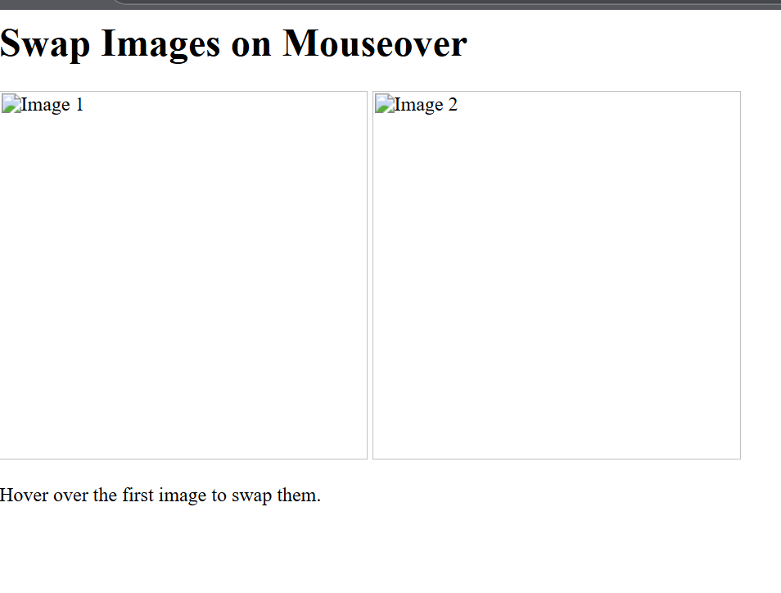

Q29 Write a simple JavaScript program to sort an array

Input:

<html>

<head>

<title>Sort an Array in JavaScript</title>

<script>

function sortArray() {

var arr = [5, 3, 8, 1, 2, 7];

arr.sort(function(a, b) {

return a - b;

document.getElementById('result').innerHTML = "Sorted Array: " + arr;

}

</script>

</head>

<body>

<h1>Sort an Array in JavaScript</h1>

<button onclick="sortArray()">Sort Array</button>

<p id="result"></p>

</body>

</html>

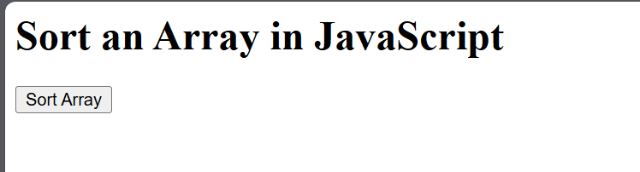

Q30 Write a JavaScript program to take as input three numbers from the user. Find the minimum and maximum of the three numbers. Print the following output in BOLD in the following format:

MINIMUM =        MAXIMUM =

Input:

<html>

<head>

<title>Find Minimum and Maximum</title>

<script>

function findMinMax() {

var num1 = parseFloat(document.getElementById('num1').value);

var num2 = parseFloat(document.getElementById('num2').value);

var num3 = parseFloat(document.getElementById('num3').value);

var min = Math.min(num1, num2, num3);

var max = Math.max(num1, num2, num3);

document.getElementById('minOutput').innerHTML = "<b>MINIMUM = " + min + "</b>";

document.getElementById('maxOutput').innerHTML = "<b>MAXIMUM = " + max + "</b>";

}

</script>

</head>

<body>

<h1>Find Minimum and Maximum of Three Numbers</h1>

<label for="num1">Enter first number:</label>

<input type="number" id="num1" required><br><br>

<label for="num2">Enter second number:</label>

<input type="number" id="num2" required><br><br>

<label for="num3">Enter third number:</label>

<input type="number" id="num3" required><br><br>

<button onclick="findMinMax()">Find Min and Max</button>

<p id="minOutput"></p>

<p id="maxOutput"></p>

</body>

</html>

